**Software Design and analysis**

**Section (B)**

Hospital Management system

(HMS)

Project proposal

Ibrar Babar (p19-0104)

**Note:** The project is Web based. In this proposal you will find description, attributes, class diagram and screenshots of the project.

Check the attached files to access Mysql file all php files used for this project.

* Actors
* Patient
* Doctor
* Nurse
* Chemist
* Laboratory
* Nurse
* Use Case

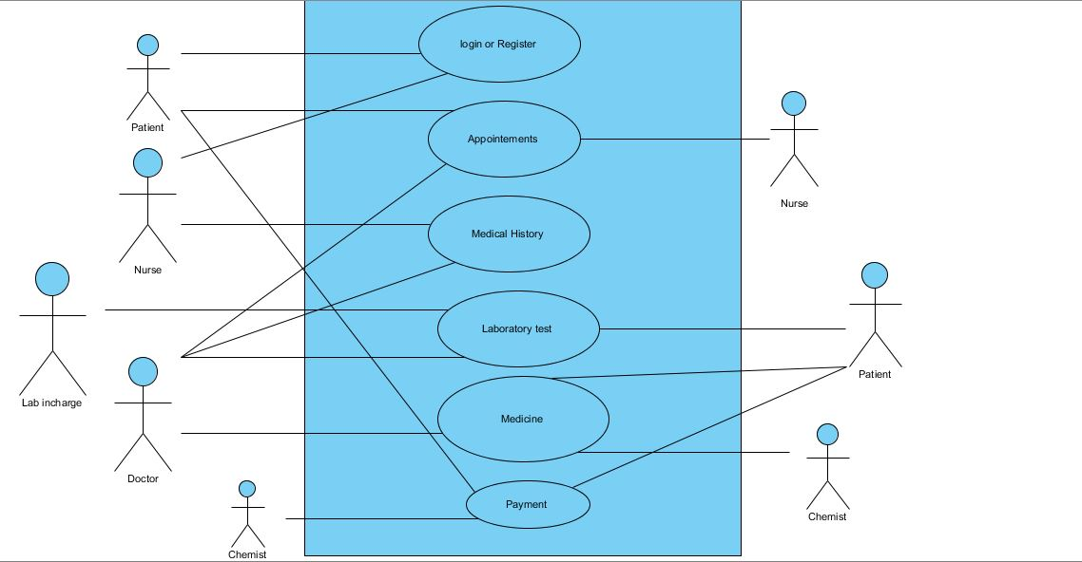

* Set of Classes/Objects in the HMS

**Classes**

* Person
* HMS
* Reception
* Register Patient
* Available Patients
* Doctor Portal
* Available Doctors
* Check Available Patients
* Receipt

**NOTE:** There attributes will be in class diagram.

**Associations**

Classes are interlinked with each other in a way, so that each patient get all the facilities which are required to every patient.

Firstly, a person come to hospital if he/she feel any sickness. Then he/she go to Reception to register his name, once his information entered then he is now a patient. He/she go to the consultant doctor, Doctor checkup him/her. In order to take tests of patient, the patient will be taken to the Lab for tests, and then after tests, the report sent to the Consultant Doctor. If needed Consultant doctor call the junior doctor to checkup the particular Patient. After that the Patient will be go to ward for further treatment and will be entertained by Nurse.

**Class Diagram**

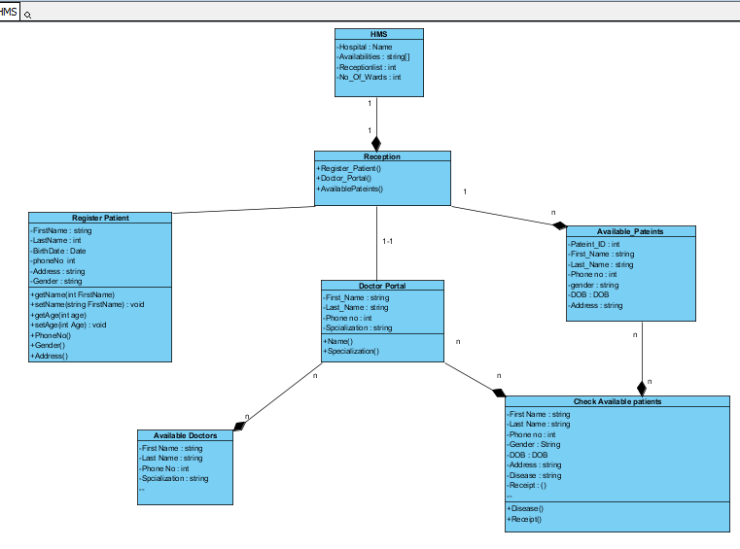

Screenshots of Project

